

Thomas Cook Ring Fenced Project
Plastics Reduction in the Hotel industry in Cyprus
June – October 2011
Final Report

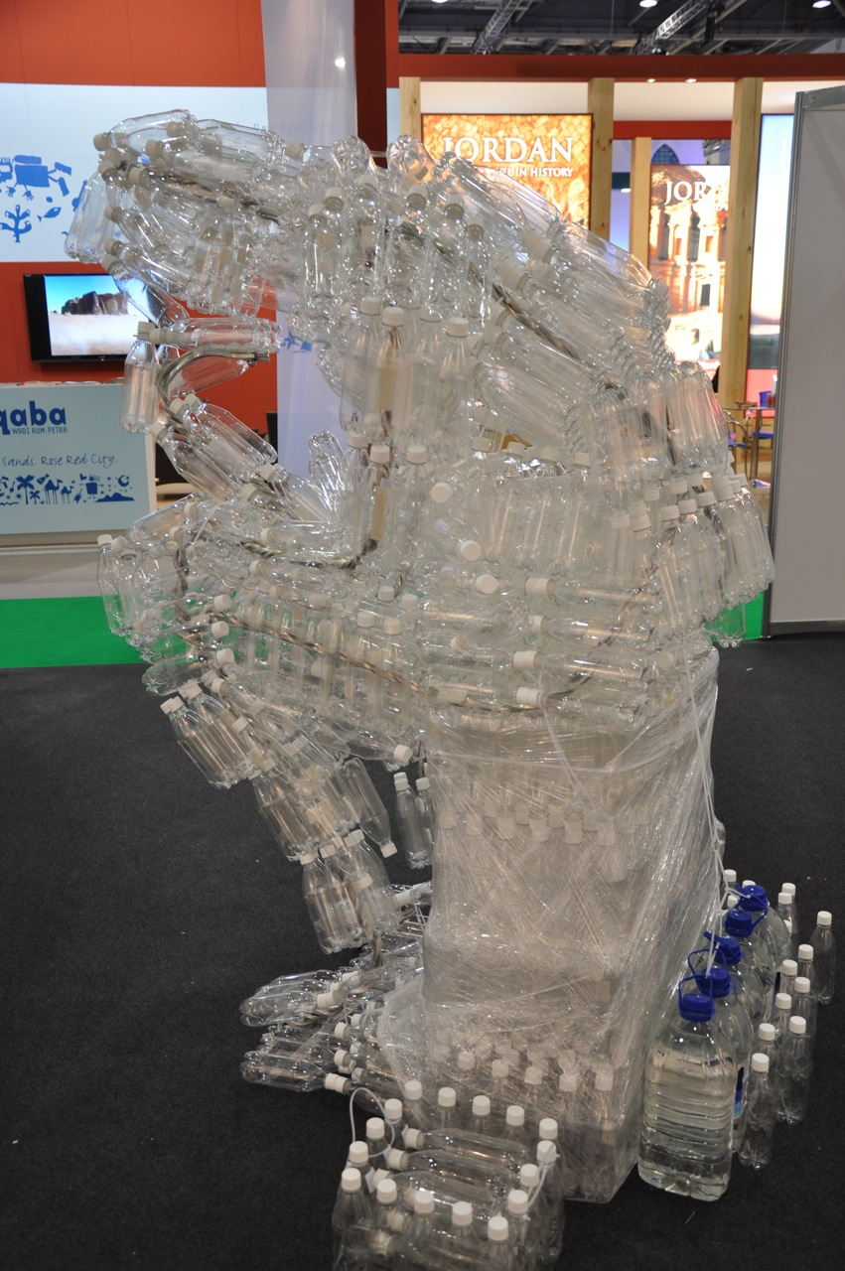

Project Co-ordinators: Dana Slavikova
Nadia Moniatis

Project Manager: Andreas Kassinos (CSTI)

Project Associates: Costas Michael (CSTI)
Philippos Drousiotis (CSTI)

The Travel Foundation, The Create Centre, Smeaton Road, BRISTOL BS1 6XN
Tel: 0117 9273 049 Email: admin@thetravelfoundation.org.uk
Web: www.thetravelfoundation.org.uk
Background

In 2010 a pilot plastic reduction project was carried out in the resort of Paphos with the objective of reducing the use of plastic items within, Thomas Cook contracted hotels and reducing plastic bag use with Thomas Cook guests in self-catering properties. The reduction of plastic items with hotels achieved good results, was relatively easy to implement and was well received by hotel guests. One hotel in particular achieved excellent results by replacing single use plastic cups with multi-use durable cups. As this hotel is part of a chain of hotels, the business benefits together with the impact on the environment were clearly identified by the management team. With a clear enthusiasm for this project, it was decided to extend it to further hotels in 2011 in the resorts of Paphos and Agia Napa/Protaras.

Project objective

To bring about a 10% reduction in plastic waste at the participating hotels. To be achieved through collaboration with Thomas Cook destination staff, management and personnel of up to 50 hotels, as well as the guests at these hotels.

Activities

Following the presentation of the 2010 plastic reduction project to a number of hotel owners and managers, Thomas Cook provided a preliminary list of hotels in Paphos and Agia Napa/Protaras regions for the project co-ordinators to approach to take part, with support from the Thomas Cook quality assurance managers in each area and CSTI board members. As a result the following hotels agreed to participate:-

Agia Napa and Protaras participating hotels

- Anastasia Beach Hotel
- Marlita Beach Hotel
- Tsokkos Gardens Hotel
- Tsokkos Protaras Beach Hotel
- Odessa Beach Hotel
- Constantinos the Great Beach Hotel
- Vissiana Beach Boutique Hotel
- Iliada Hotel
- Silver Sands Beach Hotel
- Antigoni Hotel
- Anmaria Beach Hotel
- Tsokkos Paradise Village Hotel Apartments
- Dome Beach Hotel
- Nissi Beach Hotel
- Olympic Resort

Paphos participating hotels

- Ascos Coral Beach Hotel
- Laura Beach Hotel
- Pafian Sun Hotel
- Pafian Park Hotel
- Riu Cypria Maris Hotel
- Riu Cypria Bay Hotel
- Kefalos Beach Hotel
- Qeen’s Bay Hotel
- Nereus Hotel
- Akteon Hotel
- Aquasol Village Hotel Apartments
- Aloe Hotel
- Helios Hotel

Each of these hotels were visited by the project co-ordinators at the beginning of the season. During these visits the project co-ordinators explained in detail the scope of the project and asked hotel managers to sign the project registration form (Appendix A).

Hotel managers were also provided with the following information:-

- Training plans for departmental staff on how to reduce the use of plastic items (Appendix B).
- A letter to circulate to their customers, to engage their support (Appendix C).
- Questionnaires for guests to complete at the end of their visit to assess their interest and support of the plastic reduction project (Appendix D).

The project co-ordinators also worked very closely with the Thomas Cook Quality Assurance Mangers and provided them with a training document for reps to help them brief their customers at welcome meetings (Appendix E). The reps were also asked to encourage guests to fill in their questionnaires and to return these to the project co-ordinators. Each hotel provided at least one notice board with information about the project (appendix F).

Monitoring and evaluation

The project co-ordinators were engaged to collect and analyse the following data (pre- and post project):
- Volume and cost of selected plastic items purchased by the participating hotels in June-October 2010 (baseline information) and during the same period in 2011 (following implementation of plastic reduction measures).
- Customer survey responses from hotel guests.

Project outputs

- Measured reduction of plastic items in hotels – Data was taken from a total of 20 hotels and compared over a 4 to 5 month period. Not all hotels gave full data and 7 hotels did not give sufficient data to be included in the final results although they had implemented some of the changes to save plastic items. (See Projects Outcomes section)
- Training for hotel staff and support throughout the project on how to reduce plastic in each hotel department – All hotels received regular visits and training from the project co-ordinators.
- Increased employee awareness with respect to the reduction of plastic - Trained personnel exported their knowledge to the realms of their personal life. (See Project Outcomes section)
- Increase in customer awareness in the need to reduce plastic consumption and waste -
641 questionnaires were returned from 13 hotels in Agia Napa/Protaras and 11 hotels in Paphos. (See Project Outcomes section)

Project guidelines

Hotels were presented with the following guidelines:-

- Replace one use plastic cups with multi-use durable cups for use around the pool area
- Replace bottled water with drinking water dispensers served in durable cups
- Stop the use of bin liners in the bedrooms and use in bathrooms only
- Train hotel employees to use the correct size and thickness of plastic liners
- To change plastic liners only when soiled
- To consider alternative options to wrapping glasses in plastic in bathrooms
- Discontinue the wrapping of fruit baskets with plastic
- Use refillable dispensers rather than individual packaging for soap and shampoos
- To provide straws only when requested from hotel guests
- To purchase cleaning materials in bulk
- To collect garden waste in trolleys instead of plastic liners

Project outcomes

Measured Reduction of Plastic Items in Hotels

Participating hotels saved an average of 19% of the total number of plastic items

Reduction of plastic cups
- 2 hotels had changed to durable cups in 2010 and used these exclusively in the 2011 season.
- 8 hotels introduced durable cups in 2011 but still had one use plastic cups to use up from the previous season.
- 18 hotels kept using single use plastic cups.
- On average hotels ended up using more single use plastic cups. This was due to the fact that so many had stopped offering bottled water to guests and had not changed to multi-use durable cups.

49,000 plastic cups were saved by Ascos Coral Beach Hotel and 69,075 plastic cups were saved by Dome Hotel by changing from single use plastic cups to multi-use durable cups. This represented a total saving of €5300.

Reduction of Bottled Water
- 26 hotels replaced the use of bottled water for All Inclusive guests with drinking water supplied from dispensers.
- 2 hotels continued to supply bottled water to guests.
- 2 hotels located on popular beaches open to non-resident guests saw a rise in the consumption of bottled water especially during the high summer. But these were the only hotels to have an increase in bottled water

793,916 plastic bottles of water have been saved from disposal in landfill

1.33 plastic bottles of water have been saved on average per each guest each day

Reduction of other plastic items
- All hotels were asked to reduced bin liners; straws and use of plastic in all areas of the hotel (see project guidelines).
- Hotels followed these guidelines to varying degrees. Spot checks revealed that in some cases these initiatives were not always adhered to.

The total number of plastic items saved (normalised to 2011 guest night numbers) = 2.2 million over a comparison period of only 4 to 5 months.

N.B. The difference between the percentage saving of number of items and weight is explained by the various plastic items having different weights, and substitution. For example, we think guests, in part switched from using heavier plastic bottles to plastic cups for their drinks; cups containing less plastic than a bottle.

Raising awareness among hotel staff

Over 1250 hotel were trained from housekeeping, maintenance and front office from 28 hotels over the duration of the project.

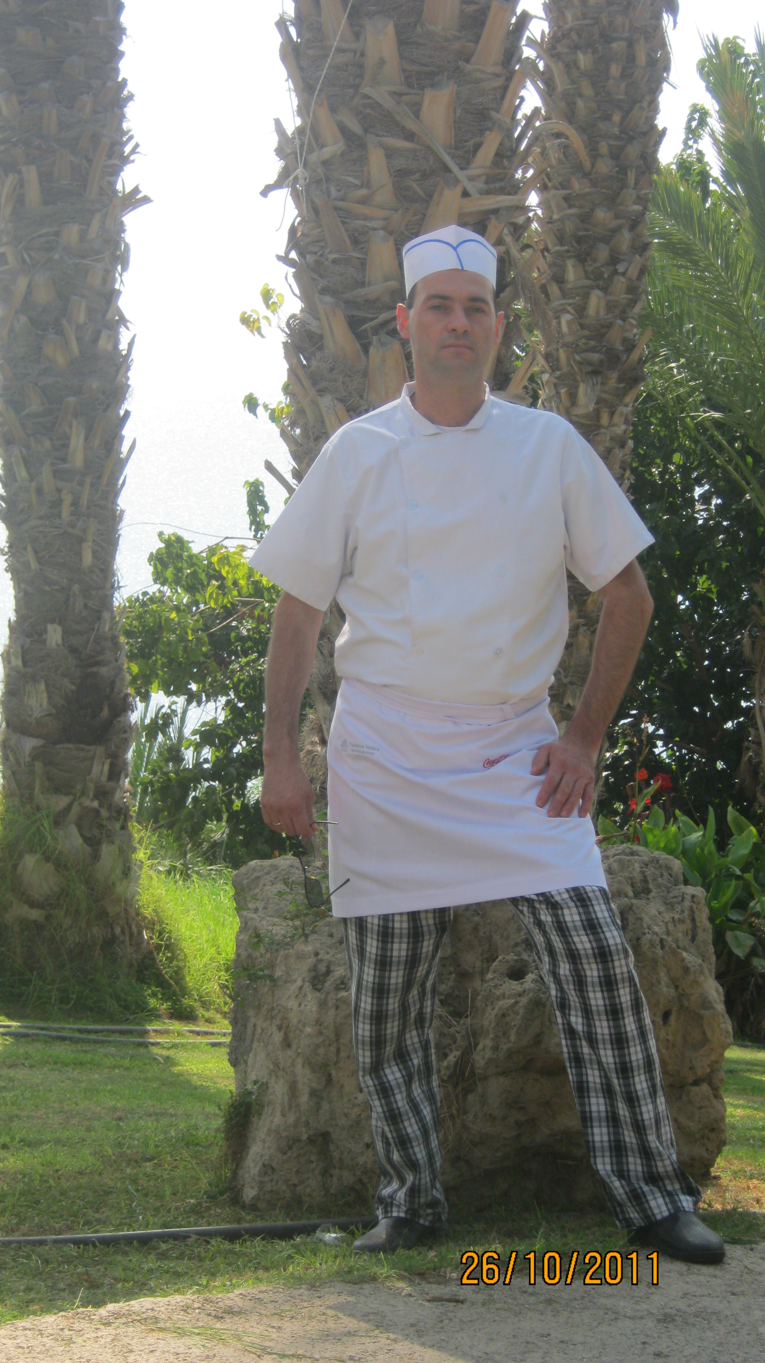
“I used to use Clingfilm without caring; now I hardly use it at all. We don’t wrap the fruit baskets in plastic and we use reusable plastic covers for salads. We’ve also changed to washable plastic containers for storing food. I like this project because it is good for the environment. I don’t use plastic bags anymore when I shop”

Yoan Zhechev Belchev, Chef at Ascos Coral Beach Hotel

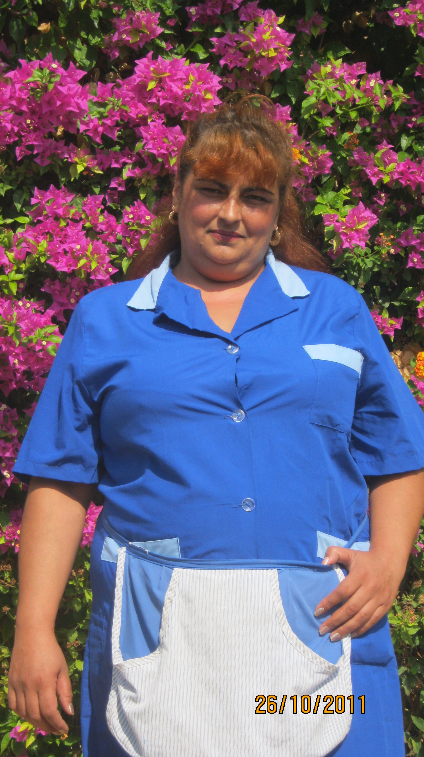
“I have changed the way I work. I now empty the plastic bags into large rubbish bins rather than changing them each time. I feel really positive about this project and I’m pleased I am doing something good for the environment. I have children and grandchildren. We have to do something good for future generations.”

Sonia Archikova, Cleaner, Ascos Coral Beach Hotel

Raising awareness among customers

641 questionnaires were returned from 13 hotels in Agia Napa/Protaras and 11 hotels in Paphos.

81% of guests reported taking one or more of the following actions:-
- 336 guests did not use plastic straws in drinks
- 328 guests re-used plastic glasses from the bar
- 295 guests re-used plastic bottles
- 188 guests purchased 5 litre water bottles instead of individual 0.5 litre bottles
- 276 guest did not use plastic cutlery around the pool

On average, each guest used 31% less plastic by weight than the same number of hotel guests did before they participated in the project

There was a good level of awareness of the project (77%), due to communications activities carried out, and guests were largely positive towards the project. As in 2010, the results of the survey revealed increases in positivity from customers towards the impact of the project on their holidays and their thoughts on Thomas Cook as a business;

- 56% said the project made them feel more positive towards Thomas Cook; 43% said it made no difference. Only 1% felt less positive.
- 50% said that the project had a positive effect on their holiday; 48% said that it had not made a difference. Only 2% said that it had had a negative effect.
- 98.4% thought the project was a good idea and 93% would like to see it rolled out in other destinations.

This positive feedback indicates that not only is it possible to introduce waste management measures without compromising the customer experience, but that customers respond positively to such initiatives and to participating companies.
Over half of customer respondents felt more positive towards Thomas Cook

50% said that plastic reduction initiative had a positive impact on their holiday

93% would like to see similar projects rolled out in other destinations

Lesson Learned

As with many other projects where data collection is a requirement it proved extremely challenging to obtain the data during what turned out to be an extremely busy season and one also plagued by problems (there were power cuts throughout the summer season due to an explosion at one of Cyprus’ main power stations). Having project co-ordinators based in each of the regions proved invaluable in this respect. Also the Tsokkos group of hotels were extremely keen to monitor results having seen what was achieved by the Ascos Coral Beach Hotel in the pilot study in the previous season. The strong relationship between Thomas Cook resort staff and this hotel group helped to reinforce the importance of the project to hotel managers.

This is one of the first projects the Travel Foundation has been involved in with a single hotel chain and it has been impressive to see the results that can be achieved when the message comes from the top down. The management team from the Tsokkos group are now looking into further initiatives that can be taken to reduce waste besides plastic items.

Initially it was hoped that 50 hotels would take part in the project but it proved difficult to recruit that many even with the support of the Thomas Cook Quality Assurance Mangers who often accompanied the project coordinators on their visits. Of the 28 hotels that signed up only 21 submitted data that could be used in the final analysis. Even though it had been clearly demonstrated that taking part in this project could help hotels save money it still proved extremely hard to engage hotel managers.

Another challenge was to get guests to complete the questionnaires. As the season progressed the project coordinators worked closely with Thomas Cook Resort staff to find the best way of achieving this. This led to the project co-ordinators turning up at hotels as big groups of guests were waiting to depart and asking them to complete the forms whilst they were waiting for the transfer bus. This system worked really well and led to the completion of over 600 questionnaires representing the views of couples and families.

The project has also demonstrated that hotels already reducing plastic can still make considerable savings. The Ascos Coral Beach Hotel made record savings for the second year running through strict implementation of all of the initiatives. The management team are now looking at other waste streams to see where they can make reductions. They have been particularly pleased by their guest’s reactions who in general perceive the hotel’s efforts to reduce plastic as a sign of their commitment to caring for the environment.

A significant result of this project is how it has demonstrated that changes can be made without impacting negatively on the customer experience and can actually influence customers’ perceptions of the businesses involved in a positive way.

The project also generated visibility for both the Travel Foundation and Thomas Cook through commissioning an artist to build a statue out of 1000 plastic bottles (the number saved each day at the Ascos Coral Beach Hotel). The statue was displayed at World Travel Market in November 2011 and received coverage in media

Despite some challenges, overall, this project has been very successful in demonstrating that significant reductions can be made in the use of plastic in hotels, with very little financial outlay, and generating considerable financial savings for the businesses involved.

During our monitoring period alone the project helped the hotels save 27.5 tonnes of plastic, equivalent to just over the weight of 26 Toyota Yaris’s

Acknowledgements

With special thanks to Tina Dobbins and Louise Auld, Thomas Cook Quality Assurance Managers, Costas Michael (CSTI Board member) and Philippos Drousiotis (CSTI Chair). Their support has been one of the main contributors to the success of this project.

